Pictiva TM 128 X 64 OLED Module (SSD0323)

Загружаем (download):

http://tanu-sha.narod.ru/Documents/Calgary128x64_2_7_AllColorsUserSpecRevB.pdf
http://tanu-sha.narod.ru/Documents/Pictiva_2_7_128x64_PRELIMINARY.pdf
http://tanu-sha.narod.ru/Documents/Treiber_IC_SSD0323_OLED_128x64_GELB.pdf
http://tanu-sha.narod.ru/Files1/Model.zip (updated)
http://tanu-sha.narod.ru/Files1/Design.zip (updated)

Распаковываем (unzip) и копируем (copy)
Model.zip LIBRARY - Program Files\Labcenter Electronics\Proteus..\ LIBRARY
MODELS - Program Files\Labcenter Electronics\Proteus..\MODELS
Design.zip – в произвольную папку (any folder)

  - В Proteus соединяем выводы (connect the pins of display and microprocessor)
по Pictiva_2_7_128x64_PRELIMINARY.pdf
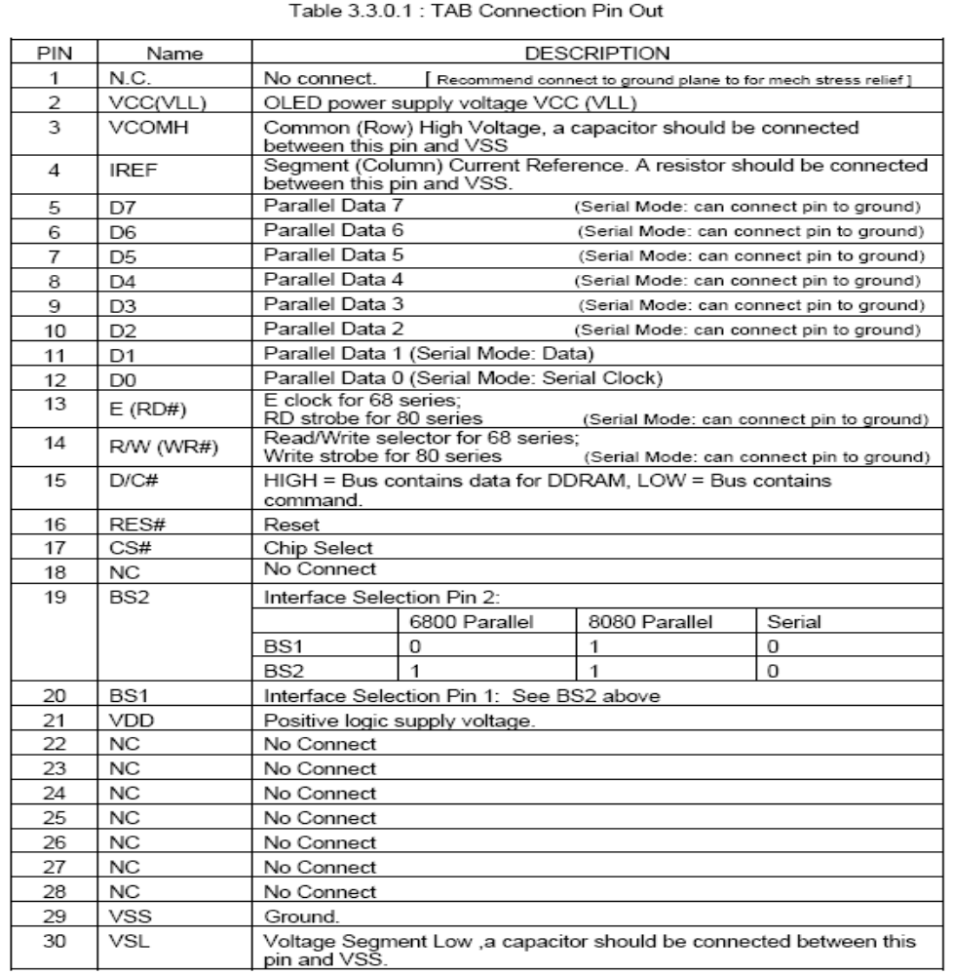

Получаем
(see “tm128x64.dsn”)

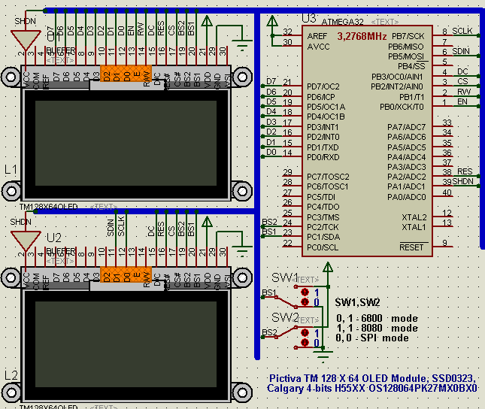

  - Описываем выводы (“pins.h”)

// pins.h

#define GLCD_SHDN_Dir DDRA
#define GLCD_SHDN_oPort PORTA
#define GLCD_SHDN_bit bit1 // PA1 - SHDN
#define GLCD_RES_Dir DDRA
#define GLCD_RES_oPort PORTA
#define GLCD_RES_bit bit2 // PA2 - RES

#define GLCD_SPI_Dir DDRB
#define GLCD_SCLK_oPort PORTB
#define GLCD_SCLK_bit bit7 // PB7 - SPIM_CLK
#define GLCD_SDIN_oPort PORTB
#define GLCD_SDIN_bit bit5 // PB5 - SPIM_MOSI
#define GLCD_DC_Dir DDRB
#define GLCD_DC_oPort PORTB
#define GLCD_DC_bit bit3 // PB3 - DC
#define GLCD_CS_Dir DDRB
#define GLCD_CS_oPort PORTB
#define GLCD_CS_bit bit2 // PB2 - CS
#define GLCD_WR_Dir DDRB
#define GLCD_WR_oPort PORTB
#define GLCD_WR_bit bit1 // PB1 - RW
#define GLCD_EN_Dir DDRB
#define GLCD_EN_oPort PORTB
#define GLCD_EN_bit bit0 // PB0 - EN

#define BS_iPort PINC
#define BS_2 bit2
#define BS_1 bit1
#define M68_mod BS_2
#define I80_mod (BS_2|BS_1)
#define SPI_mod 0

#define GLCD_Data_Dir DDRD
#define GLCD_Data_oPort PORTD
#define GLCD_Data_iPort PIND

2. Пишем функции управления для дисплея (control functions)
по временным диаграммам Calgary128x64_2_7_AllColorsUserSpecRevB.pdf

Parallel Interface Timing Diagram for 68 Series MPU

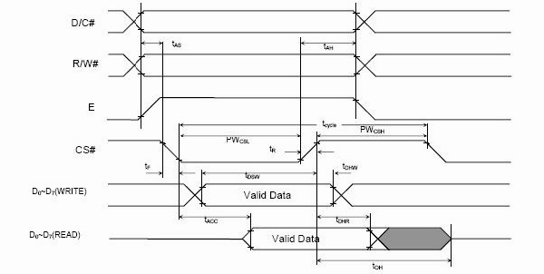

Parallel Interface Timing Diagram for 80 Series MPU
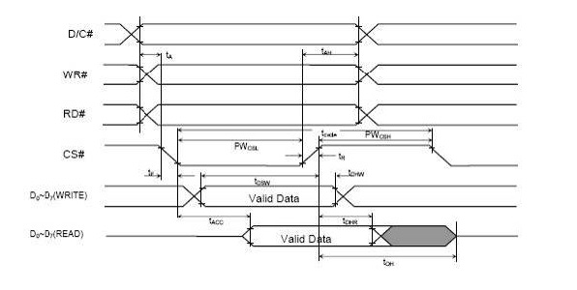

Serial Interface Timing Diagram
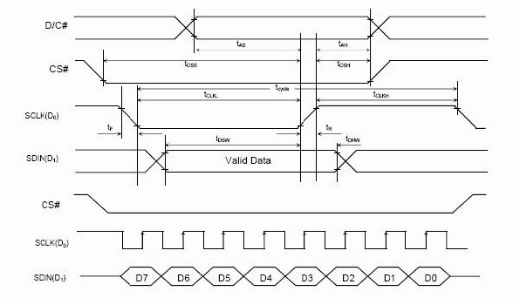
// oled.h

void comm_out(byte i) {
switch (OLED_interface) {
case SPI_mod:
GLCD_DC_oPort &= ~GLCD_DC_bit; // DC[RS]=0 - command
GLCD_CS_oPort &= ~GLCD_CS_bit; // CS=0
SPIM_1_SendTxData(i);
while (!(bSPIM_1_ReadStatus() & SPIM_1_SPIM_SPI_COMPLETE)) ;
GLCD_CS_oPort |= GLCD_CS_bit; // CS=1
GLCD_EN_oPort &= ~GLCD_EN_bit; // EN=0
GLCD_WR_oPort |= GLCD_WR_bit; // WR=1 - NO write
GLCD_DC_oPort |= GLCD_DC_bit; // DC=0 - data
break;
case M68_mod:
GLCD_Data_Dir |= 0xFF;
GLCD_DC_oPort &= ~GLCD_DC_bit; // DC[RS]=0 - command
GLCD_WR_oPort &= ~GLCD_WR_bit; // RW(WR#)=0 - write
GLCD_EN_oPort |= GLCD_EN_bit; // EN(RD#)=1
GLCD_CS_oPort &= ~GLCD_CS_bit; // CS=0
GLCD_Data_oPort = i;
GLCD_CS_oPort |= GLCD_CS_bit; // CS=1
GLCD_EN_oPort &= ~GLCD_EN_bit; // EN=0
GLCD_WR_oPort |= GLCD_WR_bit; // WR=1 - NO write
GLCD_DC_oPort |= GLCD_DC_bit; // DC=0 - data
break;
case I80_mod:
GLCD_Data_Dir |= 0xFF;
GLCD_DC_oPort &= ~GLCD_DC_bit; // DC[RS]=0 - command
GLCD_EN_oPort |= GLCD_EN_bit; // EN(RD#)=1
GLCD_WR_oPort &= ~GLCD_WR_bit; // RW(WR#)=0 - write
GLCD_CS_oPort &= ~GLCD_CS_bit; // CS=0
GLCD_Data_oPort = i;
GLCD_CS_oPort |= GLCD_CS_bit; // CS=1
GLCD_WR_oPort |= GLCD_WR_bit; // WR=1 - NO write
GLCD_EN_oPort |= GLCD_EN_bit; // EN=1
GLCD_DC_oPort |= GLCD_DC_bit; // DC=0 - data
break;
}
}

void data_out(byte i) {
switch (OLED_interface) {
case SPI_mod:
GLCD_DC_oPort |= GLCD_DC_bit; // DC[RS]=0 - data
GLCD_CS_oPort &= ~GLCD_CS_bit; // CS=0
SPIM_1_SendTxData(i);
while (!(bSPIM_1_ReadStatus() & SPIM_1_SPIM_SPI_COMPLETE)) ;
GLCD_CS_oPort |= GLCD_CS_bit; // CS=1
GLCD_EN_oPort &= ~GLCD_EN_bit; // EN=0
GLCD_WR_oPort |= GLCD_WR_bit; // WR=1 - NO write
GLCD_DC_oPort |= GLCD_DC_bit; // DC=0 - data
break;
case M68_mod:
GLCD_Data_Dir |= 0xFF;
GLCD_DC_oPort |= GLCD_DC_bit; // DC[RS]=0 - data
GLCD_WR_oPort &= ~GLCD_WR_bit; // RW(WR#)=0 - write
GLCD_EN_oPort |= GLCD_EN_bit; // EN(RD#)=1
GLCD_CS_oPort &= ~GLCD_CS_bit; // CS=0
GLCD_Data_oPort = i;
GLCD_CS_oPort |= GLCD_CS_bit; // CS=1
GLCD_EN_oPort &= ~GLCD_EN_bit; // EN=0
GLCD_WR_oPort |= GLCD_WR_bit; // WR=1 - NO write
GLCD_DC_oPort |= GLCD_DC_bit; // DC=0 - data
break;
case I80_mod:
GLCD_Data_Dir |= 0xFF;
GLCD_DC_oPort |= GLCD_DC_bit; // DC[RS]=0 - data
GLCD_EN_oPort |= GLCD_EN_bit; // EN(RD#)=1
GLCD_WR_oPort &= ~GLCD_WR_bit; // RW(WR#)=0 - write
GLCD_CS_oPort &= ~GLCD_CS_bit; // CS=0
GLCD_Data_oPort = i;
GLCD_CS_oPort |= GLCD_CS_bit; // CS=1
GLCD_WR_oPort |= GLCD_WR_bit; // WR=1 - NO write
GLCD_EN_oPort |= GLCD_EN_bit; // EN=1
GLCD_DC_oPort |= GLCD_DC_bit; // DC=0 - data
break;
}
}

byte data_inp(void) {
byte i = 0;
switch (OLED_interface) {
case M68_mod:
GLCD_Data_Dir = 0; // на прием
GLCD_DC_oPort |= GLCD_DC_bit; // DC[RS]=1 - data
GLCD_WR_oPort |= GLCD_WR_bit; // WR=1 - read
GLCD_EN_oPort |= GLCD_EN_bit; // EN=1
GLCD_CS_oPort &= ~GLCD_CS_bit; // CS=0
i = GLCD_Data_iPort;
GLCD_CS_oPort |= GLCD_CS_bit; // CS=1
GLCD_EN_oPort &= ~GLCD_EN_bit; // EN=0
GLCD_WR_oPort |= GLCD_WR_bit; // WR=1 - NO write
break;
case I80_mod:
GLCD_Data_Dir = 0; // на прием
GLCD_DC_oPort |= GLCD_DC_bit; // DC[RS]=1 - data
GLCD_WR_oPort |= GLCD_WR_bit; // WR=1 - no write
GLCD_EN_oPort &= ~GLCD_EN_bit; // EN(RD#)=0 - read
GLCD_CS_oPort &= ~GLCD_CS_bit; // CS=0
i = GLCD_Data_iPort;
GLCD_CS_oPort |= GLCD_CS_bit; // CS=1
GLCD_EN_oPort |= GLCD_EN_bit; // EN=1 - NO read
GLCD_WR_oPort |= GLCD_WR_bit; // WR=1 - NO write
break;
}
return (i);
}

3. Добавляем функции инициализации дисплея (add init function)
по Treiber_IC_SSD0323_OLED_128x64_GELB.pdf

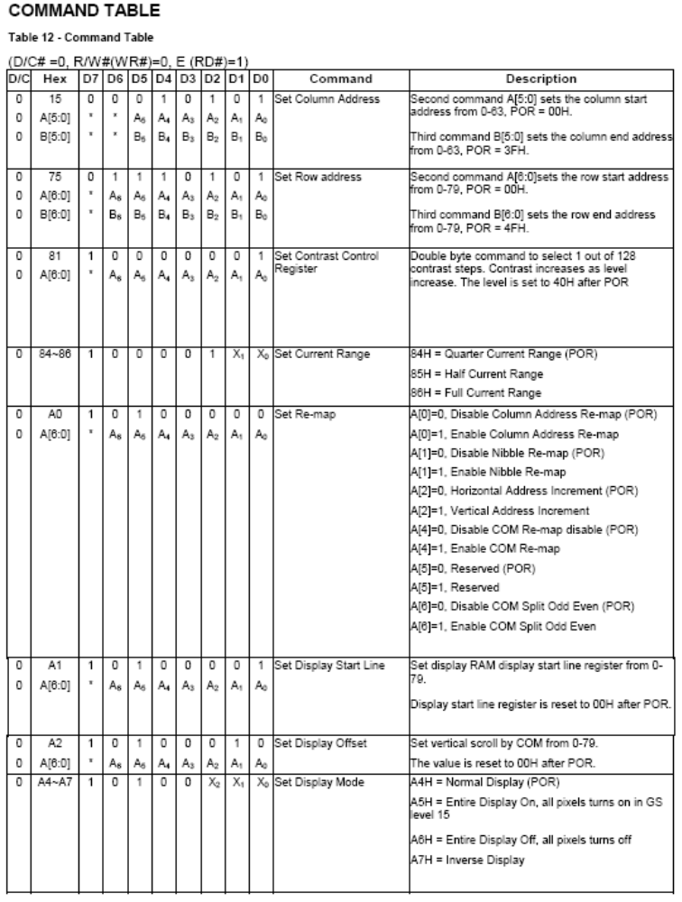

// oled.h

void delay_ms(word t) {
while (t--);
}

// A[0]=0, 0b00xxxxx0 Disable Column Address Re-map (POR)
// A[0]=1, 0b00xxxxx1 0x01 Enable Column Address Re-map
#define Column_Address_Remap bit0
// A[1]=0, 0b00xxxx0x Disable Nibble Re-map (POR)
// A[1]=1, 0b00xxxx1x 0x02 Enable Nibble Re-map
#define Nibble_Remap bit1
// A[2]=0, 0b00xxx0xx Horizontal Address Increment (POR)
// A[2]=1, 0b00xxx1xx 0x04 Vertical Address Increment
#define Vertical_Address_Increment bit2 // else Horizontal Address Increment
// A[4]=0, 0b00x0xxxx Disable COM Re-map (POR)
// A[4]=1, 0b00x1xxxx 0x10 Enable COM Re-map
#define COM_Remap bit4
// A[5]=0, 0b000xxxxx Reserved (POR)
// A[5]=1, 0b001xxxxx 0x20 Reserved
// A[6]=0, 0b00xxxxxx Disable COM Split Odd Even (POR)
// A[6]=1, 0b01xxxxxx 0x40 Enable COM Split Odd Even
#define COM_Split_Odd_Even bit6

const char inival[] = {
// Row Address
0x75, // Set Row Address ------------------------------------------
0x00, // Start = 0
0x3F, // End = 63
// Column Address
0x15, // Set Column Address --------------------------------------------
0x00, // Start = 0
0x3F, // End = 63
// Contrast Control
0x81, // Set Contrast Control (1) --------------------------------------
// 0x40, // default
0x7F, // =63 viva
// Current Range
0x86, // Set Current Range 84h:Quarter, 85h:Half, 86h:Full -------------
// Re-map
0xA0, // Set Re-map ----------------------------------------------------
COM_Split_Odd_Even|Column_Address_Remap, // 0x41 - OK (with Offset=0x44)
// COM_Split_Odd_Even|Nibble_Remap, // 0x42 – mirror X
// COM_Split_Odd_Even|Nibble_Remap|COM_Remap, // 0x52 – 180
// Display Start Line
0xA1, // Set Display Start Line ----------------------------------------
0x00, // Start at row 0
// Display Offset
0xA2, // Set Display Offset --------------------------------------------
/// 0x00, // Offset 68 rows
0x44, // with ReMap=0x41
/// 0x44-8,
// Display Mode
0xA4, // Set DisplaMode,A4:Normal, A5:All ON, A6: All OFF, A7:Inverse --
/// 0xA7, // Set DisplaMode,A4:Normal, A5:All ON, A6: All OFF, A7:Inverse --
/// 0xA5, // Set DisplaMode,A4:Normal, A5:All ON, A6: All OFF, A7:Inverse --
// Multiplex Ratio
0xA8, // Set Multiplex Ratio -------------------------------------------
0x3F, // 64 mux
// Phase Length
0xB1, // Set Phase Length ----------------------------------------------
0x22, // [3:0]:Phase 1 period of 1~16 clocks
// [7:4]:Phase 2 period of 1~16 clocks // POR = 0111 0100
// Set Pre-charge Compensation Enable
0xB0, // Set Pre-charge Compensation Enable ----------------------------
0x28, // Enable
// Set Pre-charge Compensation Level
0xB4, // Set Pre-charge Compensation Level -----------------------------
0x07, // Higher level
/// 0x03, // recomended
// Row Period
0xB2, // Set Row Period ------------------------------------------------
0x46, // [7:0]:18~255, K=P1+P2+GS15 (POR:4+7+29)
// Display Clock Divide
0xB3, // Set Clock Divide (2) ------------------------------------------
/// 0x91, // [3:0]:1~16, [7:4]:0~16, 100Hz
0x02, // [3:0]:1~16, [7:4]:0~16, 100Hz
// POR = 0000 0001
// VSL
0xBF, // Set VSL -------------------------------------------------------
/// 0x0D, // [3:0]:VSL
0x0B, // [3:0]:VSL
// VCOMH
0xBE, // Set VCOMH (3) -------------------------------------------------
0x02, // [7:0]:VCOMH, (0.53 X Vref = 0.53 X 15 V = 7.95V)
// VP
0xBC, // Set VP (4) ----------------------------------------------------
/// 0x10, // [7:0]:VP, (0.67 X Vref = 0.67 X 15 V = 10.05V)
0x13, // [7:0]:VP, (0.67 X Vref = 0.67 X 15 V = 10.05V)
// Gamma
0xB8, // Set Gamma with next 8 bytes -----------------------------------
0x01, // L1[2:0],
0x11, // L3[6:4], L2[2:0] 0001 0001
0x22, // L5[6:4], L4[2:0] 0010 0010
0x32, // L7[6:4], L6[2:0] 0011 1011
0x43, // L9[6:4], L8[2:0] 0100 0100
0x54, // LB[6:4], LA[2:0] 0101 0101
0x65, // LD[6:4], LC[2:0] 0110 0110
0x76, // LF[6:4], LE[2:0] 1000 0111
// Set DC-DC
0xAD, // Set DC-DC -----------------------------------------------------
0x02, // 03=ON, 02=Off
// Display ON/OFF
0xAF, // AF=ON, AE=Sleep Mode ------------------------------------------
};

void oled_init(void) {
word i;
delay_ms(2);
GLCD_RES_oPort &= ~GLCD_RES_bit; // Reset Driver IC
delay_ms(2);
GLCD_RES_oPort |= GLCD_RES_bit;
delay_ms(2);
GLCD_SHDN_oPort |= GLCD_SHDN_bit;
delay_ms(40);
GLCD_CS_oPort |= GLCD_CS_bit; // CS=1
for (i=0;i<80*64;i++) data_out(0); // =0
for (i=0;i<sizeof(inival);i++) comm_out(inival[i]);
}

4. Пишем функцию вывода изображения (screening function)
по Treiber_IC_SSD0323_OLED_128x64_GELB.pdf

Data Read / Write
To write data to the GDDRAM, input Low to R/W#(WR#) pin and High to D/C# pin for 6800-series parallel
mode and 8080-series parallel mode. For serial interface mode, it is always in write mode. In horizontal
address increment mode, GDDRAM column address pointer will be increased by one automatically after
each data write. In vertical address increment mode, GDDRAM row address pointer will be increased by
one automatically after each data write.
It should be noted that, in horizontal address increment mode, the row address pointer would be
increased by one automatically if the column address pointer wraps around. In vertical address increment
mode, the column address pointer will be increased by one automatically if the row address pointer wraps
around.

void img_out(const byte *a, byte x, byte y) {
byte i,j;
byte dx = *a++;
byte dy = (*a++) - 1;
byte x9 = x+dx-1;
comm_out(0x75); comm_out(y); comm_out(y+dy);
for (i=0;i<=dy;i++) {
comm_out(0x15); comm_out(x); comm_out(x9);
for (j=0;j<dx;j++) data_out(*a++);
}
}

5. Пишем программу (program)

// main.c

6. Компилируем (Build) “bear.hex”.

7. В открытом (in the opened design) “tm128x64.dsn” открываем свойства (open MCU properties) Atmega32 и меняем (and change) «tm128x64.hex» на «bear.hex»

8. “tm128x64.dsn” сохраняем как (save as) “bear.dsn”

9. Запускаем. (Start)

Links
- Editor - PSPad http://www.pspad.com
- Compiler – ICCAVR 6.31 http://www.imagecraft.com/
- OLED project example
http://www.cypress.com/?docID=2405
http://www.cypress.com/?docID=2404

